**Module:** Folded Cascode Operational Amplifier

**Designed by:** Mohsen Hassanpourghadi

**Date:** 1st May 2019

**Module Description:** Folded Cascode Operational Amplifier utilizes the cascode topology both on the pull down and pull up while using a current sink to fold the input transistors. It achieves high gain and medium output swing with a variability over the input common mode, while sacrificing the speed.

**Top Cell Name:** AMP_FOLDCASCODE65_v1

**Technology:** TSMC 65nm CMOS

**PINS:**

|  |  |
| --- | --- |
| Pin Lists |  |
| VDD | Supply Voltage |
| VSS | Ground |
| TP, TP2, TN2, TN, T | Bias voltages |
| IM, IP | Input Differential Voltage |
| OM, OP | Output Differential Voltage |

**Schematic Netlists:** AFC_v1.scs

**Schematic figures:**

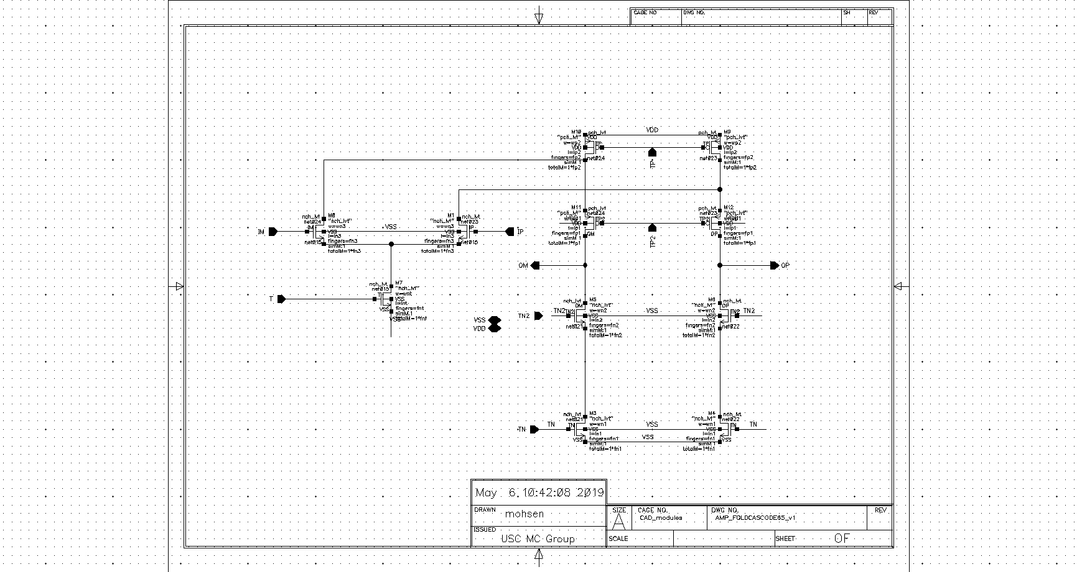

**Testbenches:** AFC_test.scs

**Parameters:**

|  |  |
| --- | --- |
| Parameters | Symbols |
| Top PMOS # of Fingers | $$fp2$$ |
| Top PMOS Length (m) | $$lp2$$ |
| Mid PMOS # of Fingers | $$fp1$$ |
| Mid PMOS Length (m) | $$lp1$$ |
| Mid NMOS # of Fingers | $$fn2$$ |
| Mid NMOS Length (m) | $$ln2$$ |
| Bot NMOS # of Fingers | $$fn1$$ |
| Bot NMOS Length (m) | $$ln1$$ |
| Input NMOS # of Fingers | $$fn3$$ |
| Input NMOS Length (m) | $$ln3$$ |
| Sink NMOS # of Fingers | $$fnt$$ |
| Sink NMOS Length (m) | $$lnt$$ |
| Sink NMOS Bias (V) | $$vttt$$ |
| Common Mode Voltage Input (V) | $$vcmin$$ |
| Common Mode Voltage Output (V) | $$vcmo$$ |
| Bot NMOS Bias (V) | $$vtn1$$ |
| Mid NMOS Bias (V) | $$vtn2$$ |
| Mid PMOS Bias (V) | $$vtp2$$ |
| Output Capacitive Load (F) | $$cl$$ |

**Metrics:**

|  |  |
| --- | --- |
| Metrics | Symbols |
| DC Power Consumption (W) | power |
| Output Swing Voltage (V) | swing |
| Common mode voltage gain (dB) | avcm |
| Differential gain (dB) | avd |
| Input Capacitance (F) | cin |
| Unity Gain Bandwidth (Hz) | gbw |
| Output Noise (V^2/Hz) | outnoise |

**Neural Network Model:**

**The H5 file:** reg_AFC65.h5

**The Json File:** model_AFC65.json

**The Input Normalization File:** scX_AFC65.pkl

**The Output Standardization File:** scY_AFC65.pkl

**The input characterization range of the Model:**

|  |  |
| --- | --- |
| Design parameters |  |
| Symbols | Characterization Range |
| $$fp2$$ | $$4,5,…, 300$$ |
| $$lp2$$ | $$[60nm, 400nm]$$ |
| $$fp1$$ | $$4,5,…, 300$$ |
| $$lp1$$ | $$[60nm, 400nm]$$ |
| $$fn3$$ | $$2,3,…, 100$$ |
| $$ln3$$ | $$[60nm, 200nm]$$ |
| $$fn2$$ | $$2,3,…, 100$$ |
| $$ln2$$ | $$[60nm, 200nm]$$ |
| $$fn1$$ | $$2,3,…, 100$$ |
| $$ln1$$ | $$[60nm, 200nm]$$ |
| $$fnt$$ | $$4,5,…, 200$$ |
| $$lnt$$ | $$[120nm, 400nm]$$ |
| $$vttt$$ | $$[0.3V, 0.6V]$$ |
| $$vcmin$$ | $$[0.6V, 1.0V]$$ |
| $$vcmo$$ | $$[0.8V, 1.2V]$$ |
| $$vtn1$$ | $$[0.4V, 0.6V]$$ |
| $$vtn2$$ | $$[0.6V, 0.95V]$$ |
| $$vtp2$$ | $$[0.0V, 0.2V]$$ |
| $$cl$$ | $$[1fF, 10pF]$$ |

**The estimation error over the metrics:**

